In the name of God Rainbow

Nona Sadeghi, class 702

Subject: A thought during Nowruz

Today I want to say that it was a long but lovely day, it may not be happy, but it was a memorable day for me.
It was a sad day, a heavy but cold spring wind was blowing. I had gone to my grandmother's house for Eid because my two uncles lived in the same building with my grandmother. On that day, we had 3 places to visit for Eid.
When I entered my grandmother's house, all my aunts were there and I went with them and everyone to my uncle's house, until this was the most boring part, because my aunt, whose daughter I am just having fun with, could not come because she is pregnant: (
After the spectacular Eid was over, I was just waiting to go home to get rid of these tight clothes and I reached my destination because one of my uncles had gone to our village and our religious Eid ended in my grandfather's building.
I was sitting by the phone with my heart broken and bored, calling my father Zang (husband is my I liked the girls of my family more) and he said let's go to the cinema and my family and I accepted and we went, but my aunt and my aunt's husband did not come because my aunt was in a bad mood and my family and my aunt went and I saw the movie Fossil. We had a good time and when he came back he invited us to stay for the night. We accepted after sitting for a long time. My unte wanted us to leave and go and buy Tajrish and Bilal, and then my aunt would get off somewhere else and shop and eat, and we would just laugh with our unte.
Until it was 4 or 5 o'clock when we got really tired and came home.

THE END
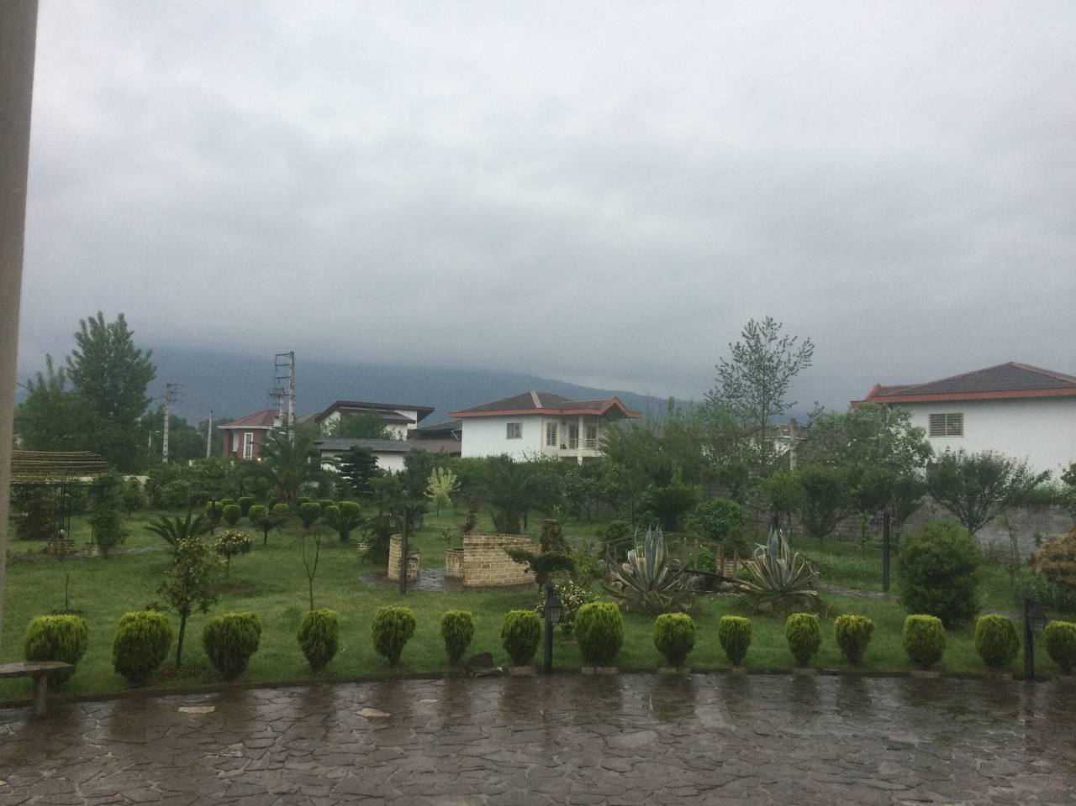
This is a photo of the fog and the beautiful nature of Masuleh

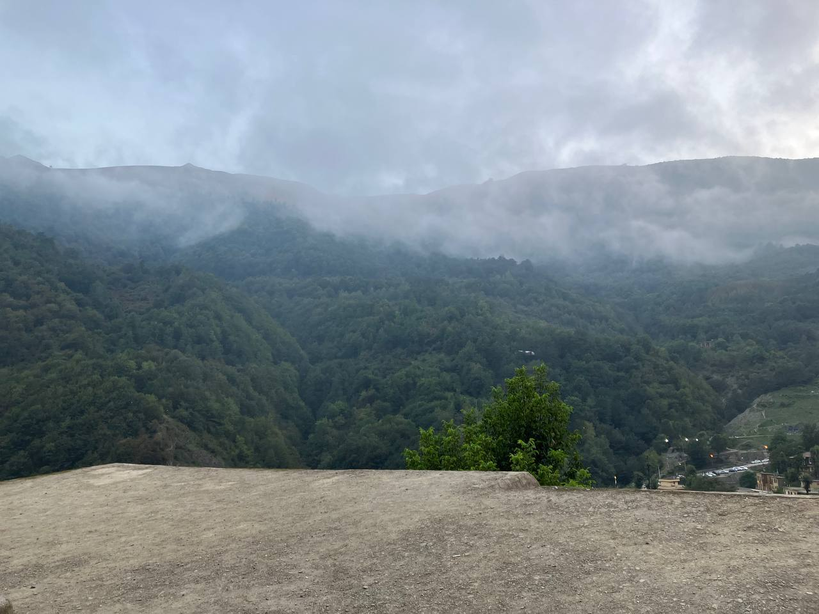
And this is a photo about fog and drizzle in the north of Iran

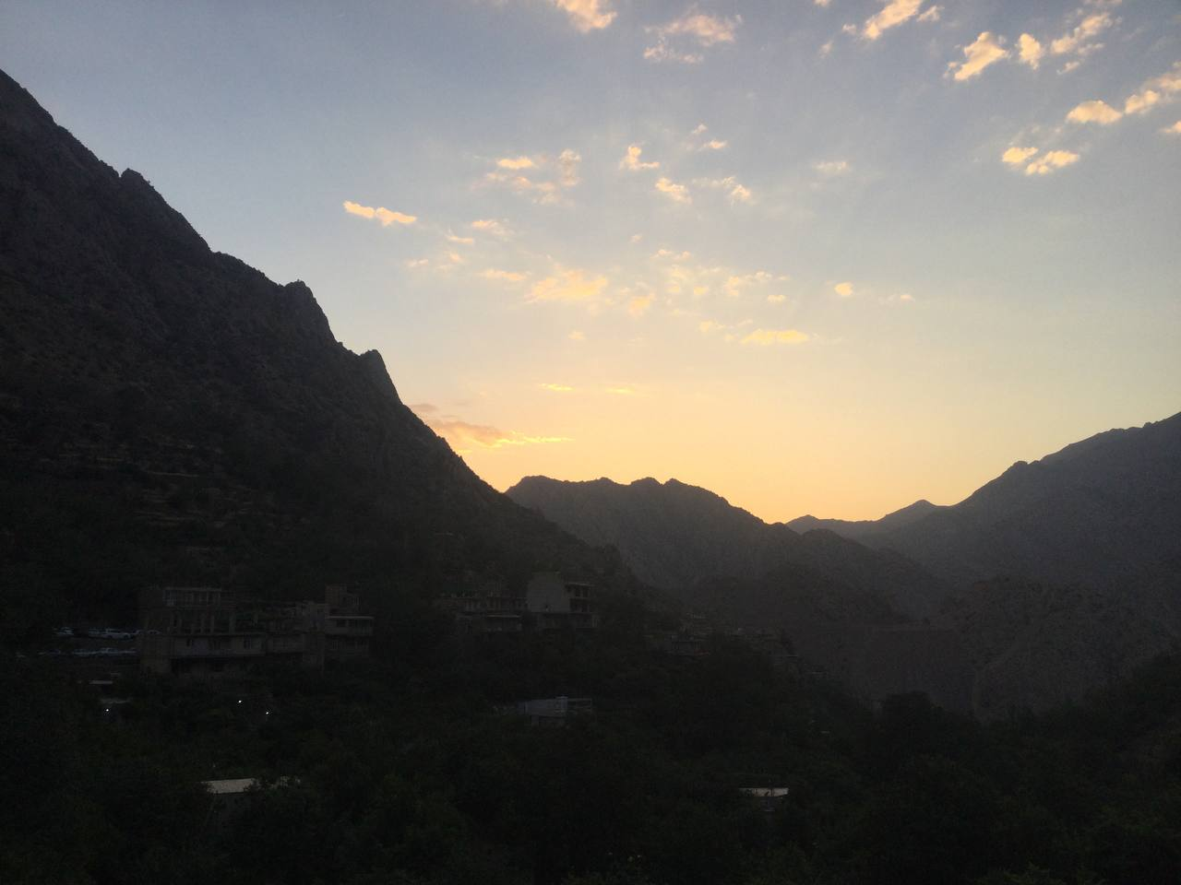
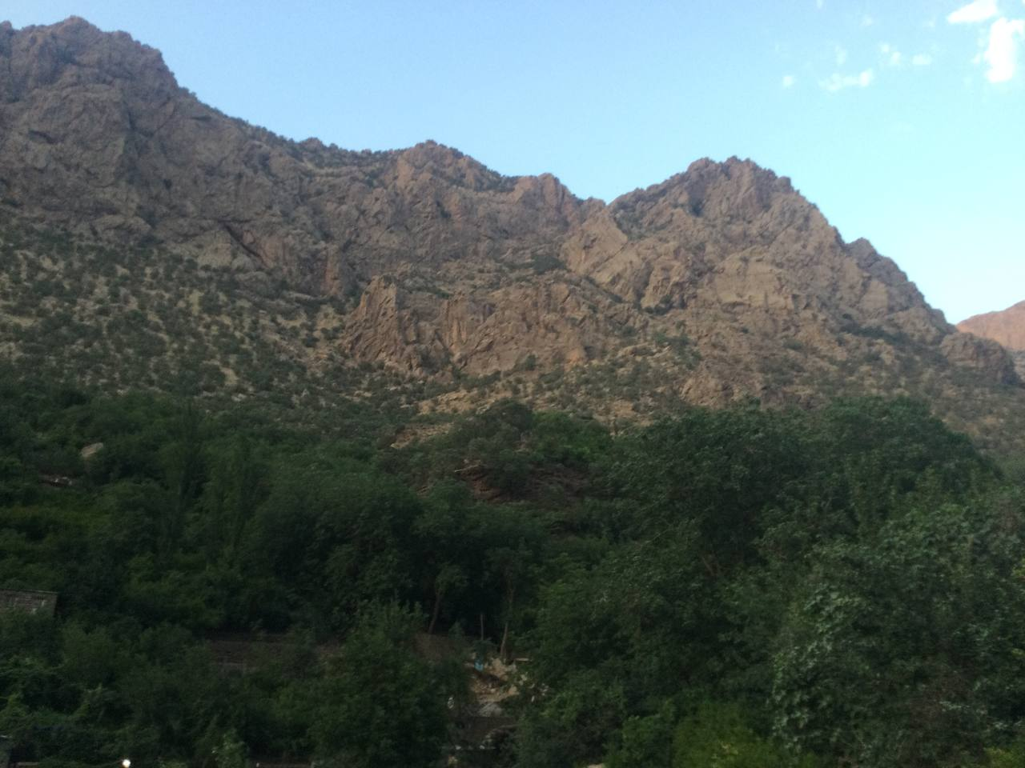
This is someone from the huge and beautiful mountains of Paveh

And this is a photo of the sun setting in Pave

