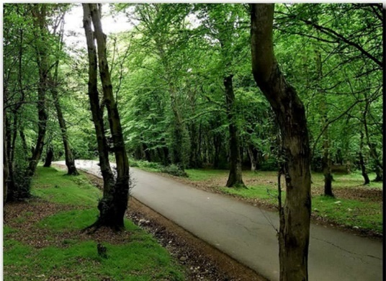
Hi, I want to talk about my journey norouz. Well we went to javarem where it is a beautiful city. my birthday is on 1st of farvardin. and we wanted to go on 29st of esfand. well I was sad cause for my birthday I couldn't be in Tehran and celebrated my birthday with my friend, but I didn’t have any other way. we went on our trip. at night we celebrated our new year and we were so happy. at the 6 am in the morning I woke up and went for walking in the forest. it was a beautiful day because it was my birthday.
Then all of our family members woke up and we ate breakfast Then we went on horse riding, playing billiards, playing splendor, drank coffee and ……….
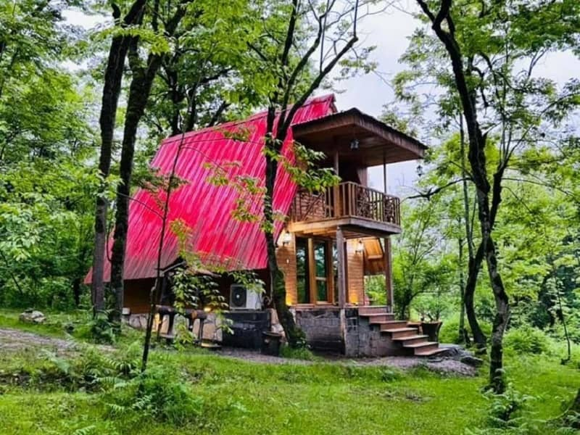
It was 6 pm that my mother and my uncle went out from villa to saw my father's friend. I was wondering that which one of my father's friend came to meet us, I wanted to go out my grandma didn’t let me go out and said its bad to go out, stay here and wait. after 30minuets later my mother called me to come out and when I went out I was surprised that 3 of my besties and my father are there and they made me surprised for my birthday. I was really shocked that they came for my birthday, when the party ended, we gave some cakes to the others villa and we were awake until 4 am in the morning. I put the pic of our villa in the down of here. this was my norouz memory

Mahsima Derakhshan , Sadeghie

